Project Done by;

|  |  |
| --- | --- |
| Name | CWID |
| Fatema Alteneiji | A20362529 |
| Moosa Hana | A20298732 |
| Saurabh Tiwari | A20356308 |
| Ernesto Garcia | A20364089 |
| Chethan Appaji | A20355296 |

Tourist Assist Application

CS487: Software Engineering

Table of contents

Application final Design 2

The application UI-Design 4

Team Performance 4

Testing 5

User Guide 5

Developer Guide 5

# Application final Design

The application was designed with a certain focus of fulfilling the main requirements, it offers a simple design that the user can easily interact with. The testing plans have been executed in order to make sure that the application can run normally without facing any exceptions, and if any were faced they were caught and handled correctly.

## The application UI-Design

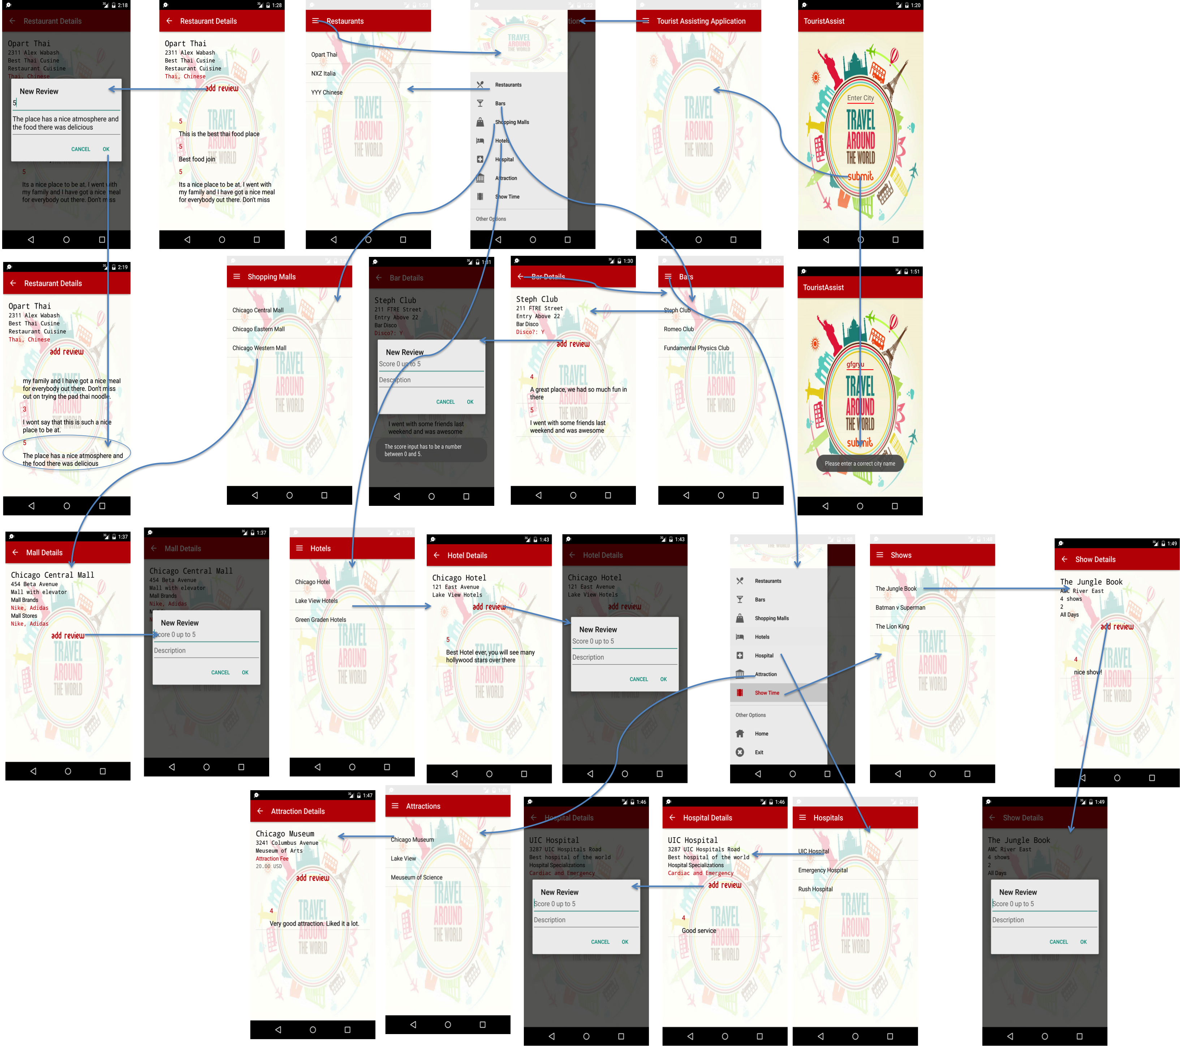

# Team Performance

# Testing

# User Guide

# Developer Guide